# Mobile Network and Location-based Services Technology Review

## Name: Shujun Bian GTID: 903172758

#### 1. Why mobile network?

Nowadays Mobile Internet becomes more and more important part in our daily life. According to a lot of surveys, the people who use mobile devices to connect to the Internet are more than the people who use desktop devices to connect to the internet. In any other word, we are in the Mobile Internet Era. The Internet is scattered with everyone calling websites intelligent website, Web 3.0, responsive websites and the Mobile Era.

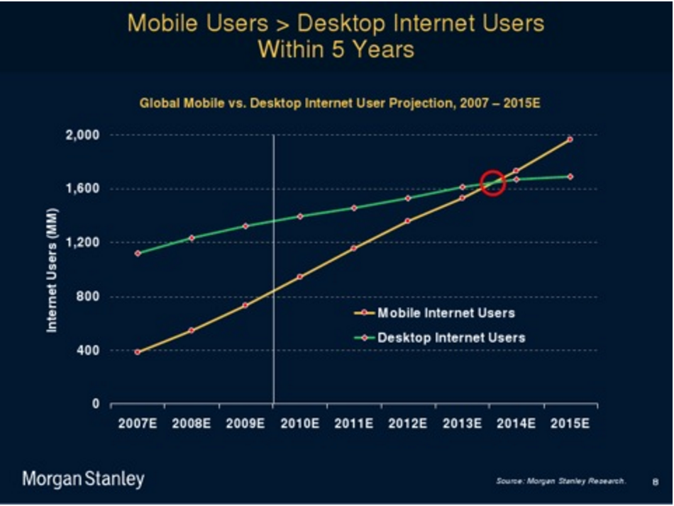

Figure1: The comparison of mobile users and desktop users current days [1]

Tablets and smartphones have changed the way people search and browse the Internet. The elements that intelligent websites now require to have are real-time updates, visually appealing design, location awareness, and high quality media. Mobile Internet is here to stay, and our social lives, that is, how we interact with others, the content we consume, and the things we buy, will be indelibly shaped by its imminent ubiquity. So the Mobile Internet technology becomes more and more important too. Mobile technology is the technology used for cellular communication. Mobile code division multiple access (CDMA) technology has evolved rapidly over the past few years. Since the start of this millennium, a standard mobile device has gone from being no more than a simple two-way pager to being a mobile phone, GPS navigation device, an embedded web browser and instant messaging client, and a handheld game console. Many experts argue that the future of computer technology rests in mobile computing with wireless networking. Mobile computing by way of tablet computers are becoming more popular. Tablets are available on the 3G and 4G networks. [2]

Different to the traditional Internet communication, how the mobile devices connecting to the Internet has its own special problem and difficulties. Because of the mobility of the mobile devices, normally it has two ways for the mobile devices communicating:

1) Mobile Network (Cellular Network)

First, what is the mobile network? A cellular network or mobile network is a communication network where the last link is wireless. The network is distributed over land areas called cells, each served by at least one fixed-location transceiver, known as a cell site or base station. This base station provides the cell with the network coverage that can be used for transmission of voice, data and others. A cell might use a different set of frequencies from neighboring cells, to avoid interference and provide guaranteed service quality within each cell. [3]

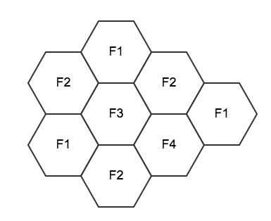

Figure2: Basic idea of mobile network

In a cellular radio system, a land area supplied with radio services is divided into some shaped cells, normally is hexagonal just as shown in the figure2. Also each cell is assigned with multiple frequencies like f1 – f6 associated with a special base station containing that frequency. The only restriction is that those adjacent neighboring cells should not use the same frequency; otherwise it would cause some confusion between different signals. We could use the mathematic method to prove that 6 different frequencies should be enough for this situation. (Four color theorem).

Also in order to distinguish signals from several different transmitters, there are several different ways to do it. Normally there are three methods as following:

1. Time division multiple access (TDMA).

2. Frequency division multiple access (FDMA).

3. Code division multiple access (CDMA).

In details, with TDMA, the transmitting and receiving time slots used by different users in each cell are different from each other. With FDMA, the transmitting and receiving frequencies used by different users in each cell are different from each other. In a simple taxi system, the taxi driver manually tuned to a frequency of a chosen cell to obtain a strong signal and to avoid interference from signals from other cells. The principle of CDMA is more complex, but achieves the same result; the distributed transceivers can select one cell and listen to it. [4]

2) Wi-Fi

Wi-Fi is another normal way for the mobile devices to connecting to the Internet. Wi-Fi or Wi-Fi is a technology that allows electronic devices to connect to a wireless LAN (WLAN) network, mainly using the 2.4 gigahertz (12 cm) UHF and 5 gigahertz (6 cm) SHF ISM radio bands. Different with mobile network, connecting with Wi-Fi requires a router and has restriction like some specific places, in the other word, if you are too far away from the router. You will lose the connection to the Internet.

#### 2. The problem caused by these two connection ways.

One significant problem caused by these two different connecting ways is that how could we maintain a stable connection when people switching from one way of connection to another. For example, a student has a phone that connects Internet through Wi-Fi in a teaching building. When he heads out to grab some food, which means he is moving out of range of the routers in the teaching building, what would happen during this period time? There might be different situations, suppose if he isn’t using his phone at that period of time then nothing special would happen. But if he is watching a video, definitely he doesn’t want any interruption during watching a video, so how could we overcome this kind of special situation? We could use multipath TCP. Through multipath TCP we could establish multiple connection based on the TCP, which means we could establish TCP connection both on the mobile network and Wi-Fi. Here is a native way to realize multipath TCP.

#### 3. Solution to the problem.

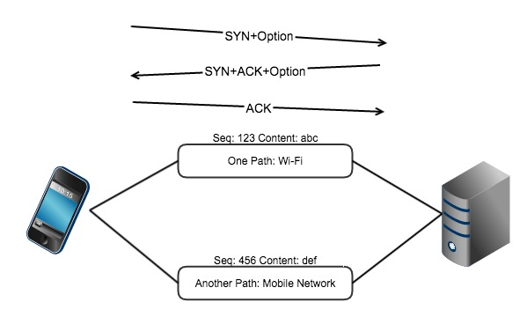

Figure3: Naïve way to realize multipath tcp

As shown in the figure3, the naïve way to build the multipath TCP is build separate connection for both Wi-Fi and Mobile Network, which causes some problem. For example, the Wi-Fi is sending the content “abc” while the Mobile Network is sending the content “def”, which if one of the connections breaks and loses some information? As we all know, TCP would only accept the packets according to the specific sequence, so if this situation happens, then all the packets would be accepted by TCP. Then we might have some other design ideas. Another idea of realizing the multipath TCP is that a multipath TCP connection is composed of one of more regular TCP sub flows that are combined. There are two main points:

1. Each host maintains state that glues the TCP sub flows that composes a multipath TCP connection together.

2. Each TCP sub flow is sent over a single path and appears like a regular TCP connection along this path.

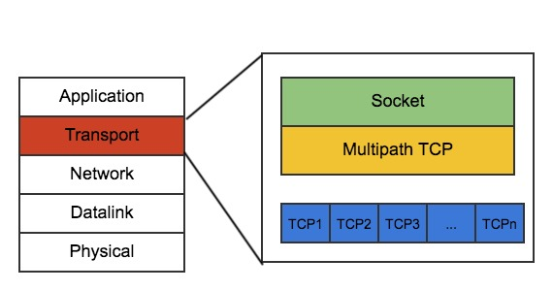

Figure4: Multipath TCP and its architecture

Figure4 shows the basic architecture of the multipath TCP, so we could add a multipath TCP layer in the Transport Layer just below the socket layer. And we could manage all sub flows (TCP connections) through the multipath TCP. All the sub flows are regular TCP: It starts with a three-way handshake SYN segments may contain special options.
All data segments are sent in sequence. There is no gap in the sequence numbers. Also the regular TCP is terminated by FIN or RST. Then we can get a more complicated idea of using the multipath TCP as shown in the figure5.

Instead of only doing the regular TCP connection one time in the naïve solution, we establish the regular TCP connection for each sub flow. In the other word, we establish TCP connection for both Wi-Fi and Mobile network. And in order to link the data from different TCP connection, in the option part of the packet, we add extra information that is called token. Through the token number, then sever would know how many different TCP connections actually stand for one mobile device. Now we can guarantee the connection between the mobile device and the server.

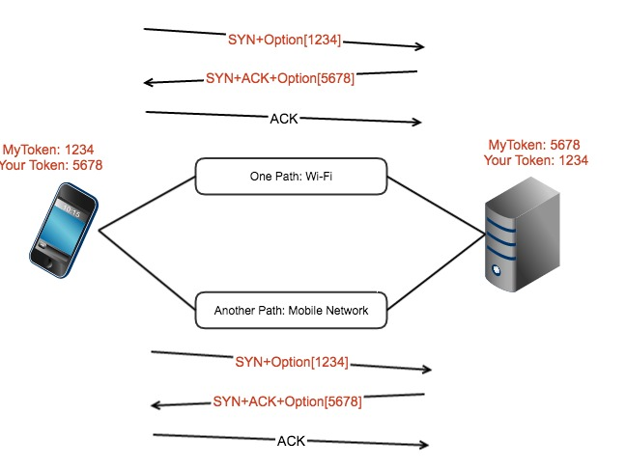

Figure5: Better solution for multipath TCP

#### 4. What’s the next step?

Since we have already solved the problem that how to communicate between the server and the mobile devices. Then the next problem should be what kind of services or functionality can we achieve only by the mobile Internet and mobile devices? Mobility is the magic word of this kind of the devices. The distinction between mobile Web applications and native applications is anticipated to become increasingly blurred, as mobile browsers gain direct access to the hardware of mobile devices (including accelerometers and GPS chips), and the speed and abilities of browser-based applications improve. Persistent storage and access to sophisticated user interface graphics functions may further reduce the need for the development of platform-specific native applications. [5] In this technology review, I may focus on one part of mobile technology and also a unique part of the Mobile Internet, mobile location based services. According to Bob Egan, Vice president of Mobile & Wireless, Gartner Group, *The Internet will not be successfully translated to the mobile world without location awareness which is a significant enabler in order to translate the Internet into a viable mobile economy.*

#### 5. What’s the location-based service?

Location-based services (LBS) are a general class of computer program-level services that use location data to control features. As such LBS is an information service and has a number of uses in social networking today as an entertainment service, which is accessible with mobile devices through the mobile network and which uses information on the geographical position of the mobile device. This has become more and more important with the expansion of the smartphone and tablet markets as well. [6] Nowadays location-based services (LBSs) is almost embedded into every mobile devices, which provides a great chance for LBSs shifting away from simply consuming location to sharing locations, and results the appearance of the location-sharing applications (LSAs). For example, there are a lot of LSAs like Google Map, twitter that take use of text-based location visualization.

Normally there are three types of location data: 1.Absolute location that comes from GPS receivers, mobile phone network, and geocoding. 2.Symbolic location (address) that comes from reverse geocoding, fixed beacon, manual entry. 3. Network location that comes from any computer or other device.

Also nowadays there are so many applications has location-based services like Facebook, Google Map, Yelp, and so on. As the figure6 shown, normally a user would contact to server through communication network (Mobile Network and Wi-Fi) and the satellite would send the positioning data to user device, here is the overview of this architecture.

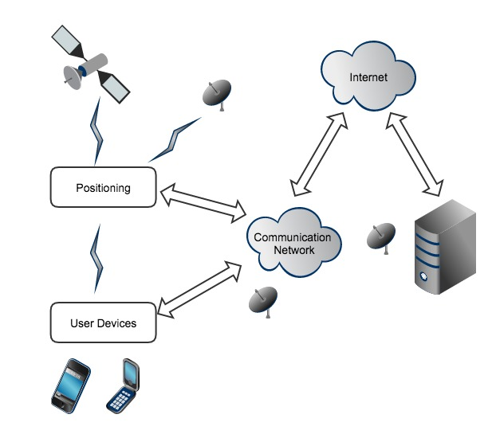

Figure6: How user devices communicate with the severs that provide location-based services

#### 6. The basic approach to location-based service in Android.

To go deep of the current location-based services, I browse some details of how to build an Android location-based application. First, we need to get an overview of how to obtain user location data. Here is the flow of how to obtaining the location data in Android. Knowing where the user is allows your application to be smarter and deliver better information to the user. When developing a location-aware application for Android, you can utilize GPS and Android's Network Location Provider to acquire the user location. Although GPS is most accurate, it only works outdoors, it quickly consumes battery power, and doesn't return the location as quickly as users want. Android's Network Location Provider determines user location using cell tower and Wi-Fi signals, providing location information in a way that works indoors and outdoors, responds faster, and uses less battery power. To obtain the user location in your application, you can use both GPS and the Network Location Provider, or just one. [7]

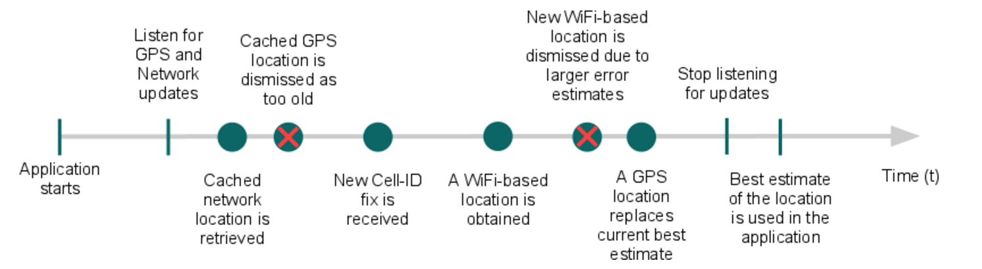

Figure7: Flow for obtaining user location [7]

In android application, we get user location through receiving the updates from locationManager(). The code is like this:

LocationManager locationManager = (LocationManager) this.getSystemService(Context.LOCATION_SERVICE);

LocationListener locationListener = new LocationListener() {

public void onLocationChanged(Location location) {  
  
    public void onStatusChanged(String provider, int status, Bundle extras) {}  
  
    public void onProviderEnabled(String provider) {}  
  
    public void onProviderDisabled(String provider) {}

};

locationManager.requestLocationUpdates(LocationManager.NETWORK_PROVIDER, 0, 0, locationListener);

Also there are many scenarios where we can use the user location to enrich our application. For example, we could tag user-created content with a location, users could share their experience associated with the location data. We could also help users know where they are or where they want to go. For example, the application like Google Map could help people to do. More applications like Yelp would also embed the map function into their app, so that it is convenient for people to look up for their favorite restaurant.

#### 7. Location-based service data.

Besides the traditional location data, nowadays, there are a lot of location-based applications with community-authored content, such as location specific reviews, which could offer a lot of useful information. There many research about it and there is paper discussing about it whose title is *Identifying the Activities Supported by Locations with Community-Authored Content.* [8] This study focuses on the Yelp’s community-authored reviews to identify a set of potential activities. Context-aware applications commonly require knowledge of a person’s location and activity based on relying on low cost sensors meanwhile this paper proposes a new way to identify potential activities by the locations a person may visit by processing community-authored reviews on Yelp. They take use of such information to build a corpus of potential activities for each location. Although, the activities they identified might not be related to that person immediately, it shows the potential possibility that that person would do in that location. In this study, they also do the evaluations of precision by user study, which shows following points:

1. Yelp reviews can be processed to identify the activities supported by the reviewed location with nice precision up to 79.3% and recall up to 55.9%.

2. The number of reviews authored for a location has a significant impact on precision.

3. There might be a difference in the activities which user identified with the reviews identified for a location.

Certainly, there are some cons and pros of this study. One of the pros is that this study is gains good mean precision of up to 79.3% and recall up to 55.9% across the 14 locations. And one of the cons is that the frequency analysis is too simple, which causes too much false positives in result, and this study might need some more sophisticated methods of natural language processing to deal with this problem. Also another of the cons might be the small sample size. Because the number of reviews authored for a location has a strong influence on precision, which encourages the study using a bigger sample size for each location in the future. The last point of the cons is that this study didn’t take the timeliness of an activity into consideration, but the timeliness of an activity has influence on activities validity.

Also, the context-aware services that provide more relevant services to the user based on current location of a mobile user could take use of the result of this study. Not only two examples provided in the paper, there are more samples flood into my head about the context-aware services. For example, we could use the result to do some prediction of where the user to go and do the recommendation. Also this prediction could combine more information like the time of the day, temperature and so on. Another great area of using the context-aware services is health care. Based on the community-authored information and hospital staff’s comment or feedback, which could speed up the process of being in treatment meantime the patients might be better taken care of through these information.

#### 8. Some problem about the location based services.

In my opinion, the location-based applications is the trend in the future, currently almost every famous applications or website would have the functionality based on the location like Yelp would recommend the restaurant, Facebook would recommend the friends all based on the location. We even could have the augmented reality game based on the location in the future. So the privacy of using this kind of location-based application would certainly be the first concern in the future. As a user, I do not want any of my personal information is leaked during the use of location-based application and I also do not want anyone else could get my privacy through the historical information in these location-based applications.

Further more, we might have some other issues beyond the technical point of view on the location-based service. Nowadays, there is an often-stated argument that national security comes before the personal privacy, for instance in the case of tracking criminals and terrorists would take advantage of the location-based service. So how to deal with the relationship between national security and personal privacy would be another problem to be considered in the area of the location-based service and applications.

#### 9. Conclusion and Future work.

In short, in this technology review, basically I reviewed through the Mobile Network and Wi-Fi, discussed what problem will be caused by these two connection ways. Also I go for the solution for this problem (multipath-TCP) from the simplest solution to a realizable solution. Then we discussed some functionality that is unique in the Mobile Internet like the location-based services. And we go through some basic location-based services data like the traditional location data (latitude, attitude) to augmented location data like the location-based comments in Yelp.com community.

There would still be a lot of future work to do. I believe the Mobile Network era is the next era in maybe 30 years, so we need to fit in it and do more research about it. We need to be familiar with how to take advantage of the Mobile Network and location-based data.

#### Reference

[1]<http://www.cheatsheet.com/technology/mobile/web-3-0-the-mobile-internet-era-is-upon-us.html/>

[2]<https://en.wikipedia.org/wiki/Mobile_technology>

[3]G. Miao; J. Zander; K-W Sung; B. Slimane (2016). Fundamentals of Mobile Data Networks. Cambridge University Press. ISBN 1107143217.

[4]<https://en.wikipedia.org/wiki/Cellular_network#cite_note-Zander-1>

[5]<https://en.wikipedia.org/wiki/Mobile_Web>

[6]<https://en.wikipedia.org/wiki/Location-based_service>

[7]<http://developer.android.com/guide/topics/location/strategies.html>

[8]Dearman D, Truong K N. Identifying the activities supported by locations with community-authored content[C]//Proceedings of the 12th ACM international conference on Ubiquitous computing. ACM, 2010: 23-32.

[9] Tang K P, Hong J I, Siewiorek D P. Understanding how visual representations of location feeds affect end-user privacy concerns[C]//Proceedings of the 13th international conference on Ubiquitous computing. ACM, 2011: 207-216.

[10] Dearman D, Truong K N. Identifying the activities supported by locations with community-authored content[C]//Proceedings of the 12th ACM international conference on Ubiquitous computing. ACM, 2010: 23-32.